PRACTICAL NO 10: Configure and Verify a Site-to-Site IPsec VPN Using CLI
IPSec’s protocol objective is to provide security services for IP packets such as encrypting sensitive data, authentication, and protection against replay and data confidentiality.
Encapsulating Security Payload (ESP) and Authentication Header (AH) are the two IPSec security protocols used to provide these security services.
Understanding IPSec Modes –Tunnel Mode & Transport Mode
IPSec can be configured to operate in two different modes, Tunnel and Transport mode. Use of each mode depends on the requirements and implementation of IPSec.

IPSec Tunnel Mode
IPSec tunnel mode is the default mode. With tunnel mode, the entire original IP packet is protected by IPSec. This means IPSec wraps the original packet, encrypts it, adds a new IP header and sends it to the other side of the VPN tunnel (IPSec peer).
Tunnel mode is most commonly used between gateways (Cisco routers or ASA firewalls), or at an end-station to a gateway, the gateway acting as a proxy for the hosts behind it.
Tunnel mode is used to encrypt traffic between secure IPSec Gateways, for example two Cisco routers connected over the Internet via IPSec VPN.

ISAKMP Overview
Internet Security Association and Key Management Protocol (ISAKMP) works with IPsec to make VPNs more scalable.
ISAKMP is the negotiation protocol that lets two hosts agree on how to build an IPsec security association. ISAKMP separates negotiation into two phases: Phase 1 and Phase 2.

Phase 1:
It creates the first tunnel, which protects later ISAKMP negotiation messages.
Phase 2:
It creates the tunnel that protects data.
To set the terms of the ISAKMP negotiations, you create an ISAKMP policy, which includes the following:
•An authentication method, to ensure the identity of the peers.
•An encryption method, to protect the data and ensure privacy.
•A Hashed Message Authentication Codes (HMAC) method to ensure the identity of the sender, and to ensure that the message has not been modified in transit.
•A Diffie-Hellman group to determine the strength of the encryption-key-determination algorithm. The security appliance uses this algorithm to derive the encryption and hash keys.
•A limit to the time the security appliance uses an encryption key before replacing it.

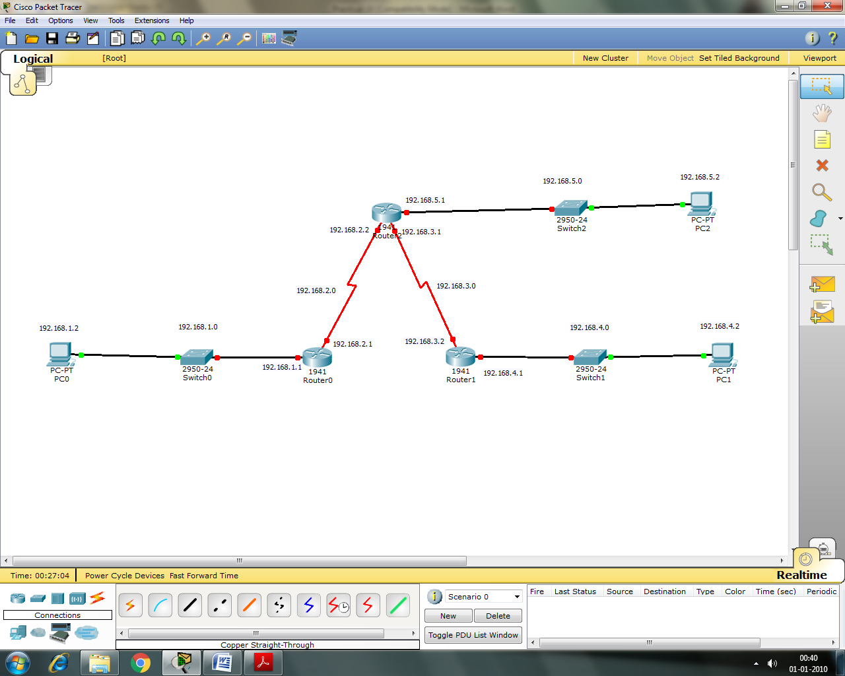
Configuring PC0
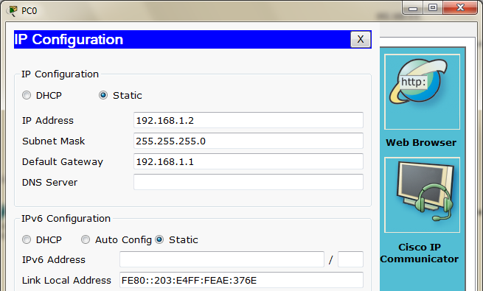

Configuring PC1
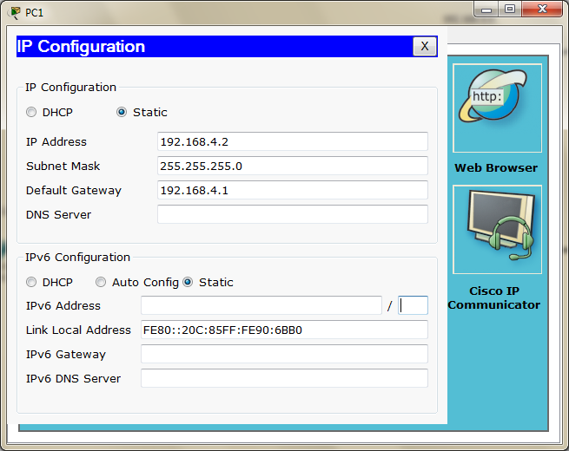

Configuring PC2
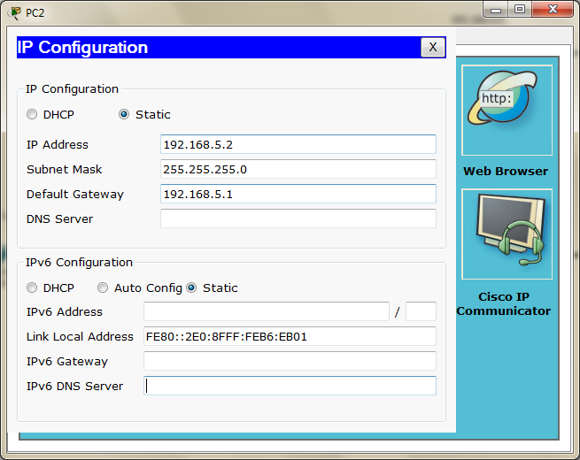

Serial Interface must be added in each Router before configuring it
Configuring Router0
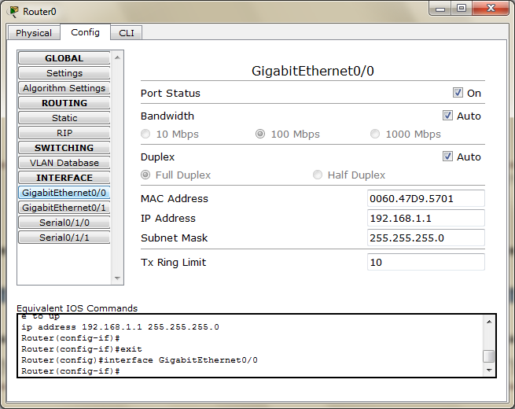
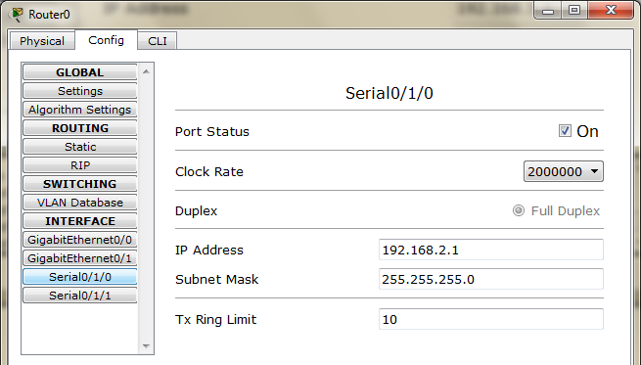

Configuring Router1
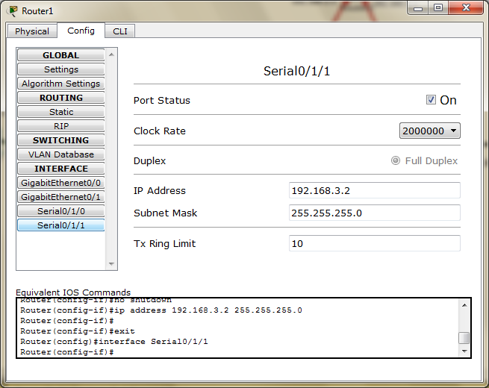

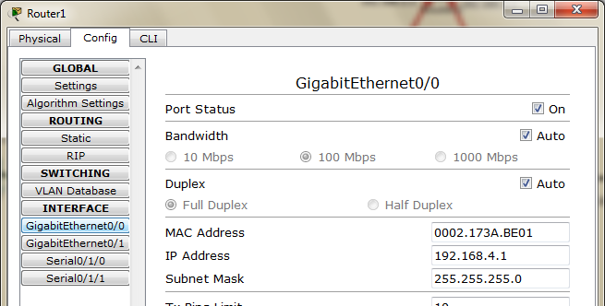

Configuring Router2
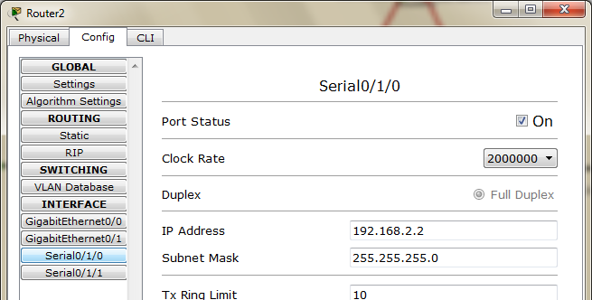

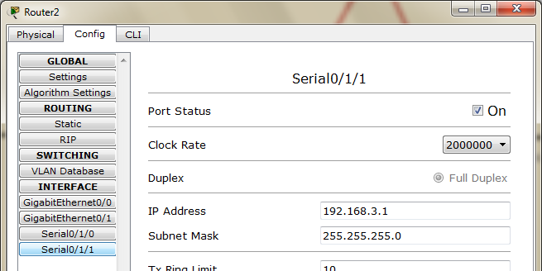
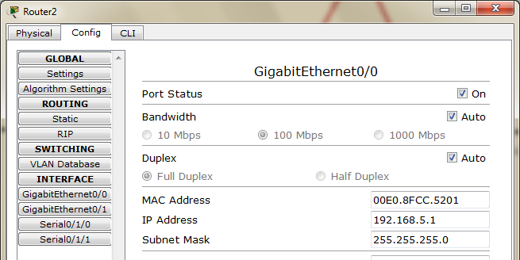

Part 1: Configuring RIP on each Router
Router 0: Add the following networks
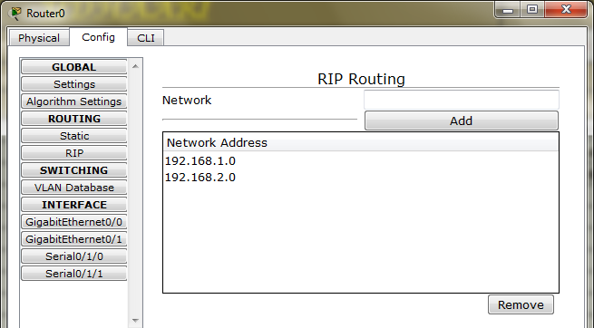
Router 1: Add the following networks
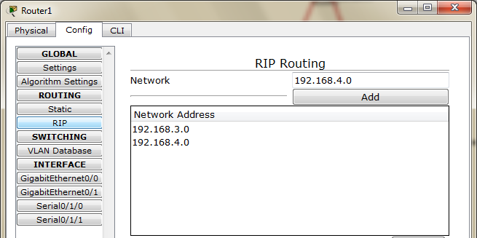

Router 2: Add the following networks
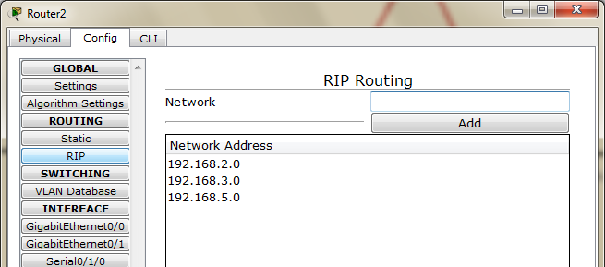

Now check the connectivity by ping command
PCO to PC1 (it should be successful)
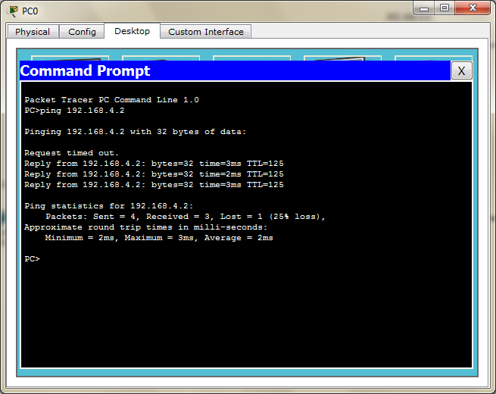

PC2 to PC0 (it should be successful)
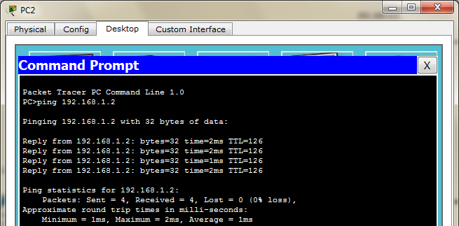

Part 2: Configure IPSec Parameters on Router0
In order to configure the IPSec parameters on Router0 we go by the following steps
Step 1: Enable the security package on Router0 through the following commands in CLI mode
Router>enable
Router#configure terminal
Router(config)#license boot module c1900 technology-package securityk9
Router(config)#do write
Router(config)#exit
Router#reload

Router>

Router>enable

Now we need to check if the security package is enabled, so we type the following command

Router#show version

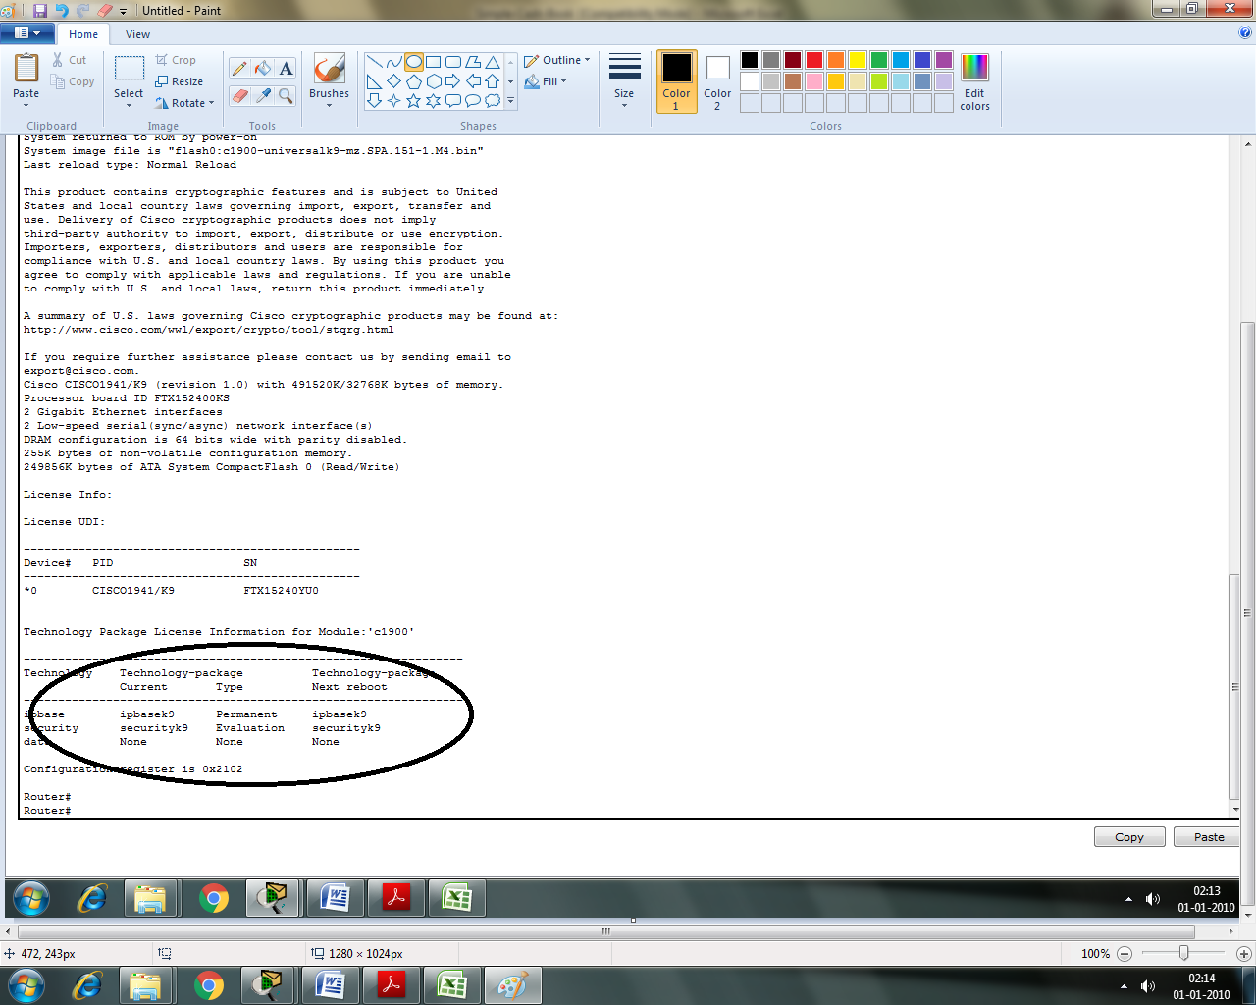

The above shows that the security package has been enabled

Step 2: Configuring IKA phase 1 ISAKMP policy on Router0
Type the following commands in the CLI mode of Router0

Router#configure terminal
Router(config)#access-list 110 permit ip 92.168.1.0 0.0.0.255 192.168.4.0 0.0.0.255
Router(config)#crypto isakmp policy 10
Router(config-isakmp)#encryption aes 256
Router(config-isakmp)#authentication pre-share
Router(config-isakmp)#group 5
Router(config-isakmp)#exit
Router(config)#crypto isakmp key sies1234 address 192.168.3.2
Router(config)#crypto ipsec transform-set vpn-set esp-aes esp-sha-hmac
Router(config)#crypto map vpn-map 10 ipsec-isakmp
Router(config-crypto-map)#set peer 192.168.3.2
Router(config-crypto-map)#set transform-set vpn-set
Router(config-crypto-map)#match address 110
Router(config-crypto-map)#exit
Router(config)#
Router(config)#interface Serial0/1/0
Router(config-if)#crypto map vpn-map
Router(config-if)#exit
Router(config)#

Part 3: Configure IPSec Parameters on Router1
In order to configure the IPSec parameters on Router1 we go by the following steps
Step 1: Enable the security package on Router1 through the following commands in CLI mode
Router>enable
Router#configure terminal
Router(config)#license boot module c1900 technology-package securityk9
Router(config)#do write
Router(config)#exit
Router#reload

Router>

Router>enable

Now we need to check if the security package is enabled, so we type the following command

Router#show version

The above shows that the security package has been enabled
Step 2: Configuring IKA phase 1 ISAKMP policy on Router1
In order to configure the IPSec parameters on Router1 we go by the following steps
Router#
Router#configure terminal
Enter configuration commands, one per line. End with CNTL/Z.
Router(config)#access-list 110 permit ip 192.168.4.0 0.0.0.255 192.168.1.0 0.0.0.255
Router(config)#crypto isakmp policy 10
Router(config-isakmp)#encryption aes 256
Router(config-isakmp)#authentication pre-share
Router(config-isakmp)#group 5
Router(config-isakmp)#exit
Router(config)#crypto isakmp key sies1234 address 192.168.2.1
Router(config)#crypto ipsec transform-set vpn-set esp-aes esp-sha-hmac
Router(config)#crypto map vpn-set 10 ipsec-isakmp
Router(config-crypto-map)#description vpn
Router(config-crypto-map)#set peer 192.168.2.1
Router(config-crypto-map)#set transform-set vpn-set
Router(config-crypto-map)#match address 110
Router(config-crypto-map)#exit
Router(config)#
Router(config)#interface Serial0/1/1
Router(config-if)#crypto map vpn-set
Router(config-if)#
Part 4: Verify the IPSec VPN

Step 1: Type the following command in the CLI mode of Router0
Router>
Router>EN
Router>enable
Router#show crypto ipsec sa

We get the following output (No packets are encrypted given in bold)

interface: Serial0/1/0
Crypto map tag: vpn-map, local addr 192.168.2.1

protected vrf: (none)
local ident (addr/mask/prot/port): (92.168.1.0/255.255.255.0/0/0)
remote ident (addr/mask/prot/port): (192.168.4.0/255.255.255.0/0/0)
current_peer 192.168.3.2 port 500
PERMIT, flags={origin_is_acl,}
#pkts encaps: 0, #pkts encrypt: 0, #pkts digest: 0
#pkts decaps: 0, #pkts decrypt: 0, #pkts verify: 0
#pkts compressed: 0, #pkts decompressed: 0
#pkts not compressed: 0, #pkts compr. failed: 0
#pkts not decompressed: 0, #pkts decompress failed: 0
#send errors 0, #recv errors 0

local crypto endpt.: 192.168.2.1, remote crypto endpt.:192.168.3.2
path mtu 1500, ip mtu 1500, ip mtu idb Serial0/1/0
current outbound spi: 0x0(0)

inbound esp sas:
inbound ah sas:
inbound pcp sas:
outbound esp sas:
outbound ah sas:
outbound pcp sas:

Step 2: Ping PC1 from PC0 (Creating interesting traffic)

We ping PC1 from PC0 (which is the interesting traffic)

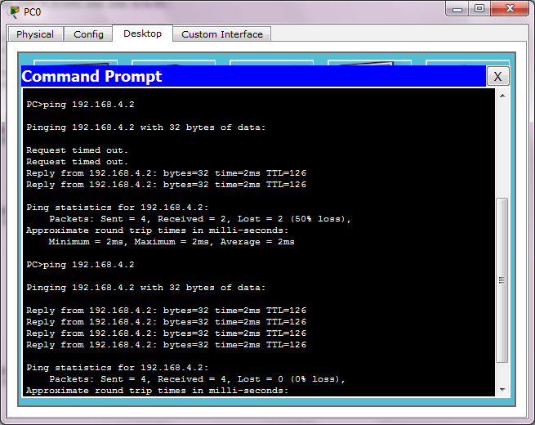

And now we check the Router0 by typing the following Command

Router#show crypto ipsec sa

We get the following output, as seen the number of packets encrypted is not zero (marked bold)

interface: Serial0/1/0
Crypto map tag: vpn-map, local addr 192.168.2.1

protected vrf: (none)
local ident (addr/mask/prot/port): (192.168.1.0/255.255.255.0/0/0)
remote ident (addr/mask/prot/port): (192.168.4.0/255.255.255.0/0/0)
current_peer 192.168.3.2 port 500
PERMIT, flags={origin_is_acl,}
#pkts encaps: 3, #pkts encrypt: 3, #pkts digest: 0
#pkts decaps: 2, #pkts decrypt: 2, #pkts verify: 0
#pkts compressed: 0, #pkts decompressed: 0
#pkts not compressed: 0, #pkts compr. failed: 0
#pkts not decompressed: 0, #pkts decompress failed: 0
#send errors 1, #recv errors 0

local crypto endpt.: 192.168.2.1, remote crypto endpt.:192.168.3.2
path mtu 1500, ip mtu 1500, ip mtu idb Serial0/1/0
current outbound spi: 0x4C85163A(1283790394)

inbound esp sas:
spi: 0x6F1C411E(1864122654)
transform: esp-aes esp-sha-hmac ,
in use settings ={Tunnel, }
conn id: 2004, flow_id: FPGA:1, crypto map: vpn-map
sa timing: remaining key lifetime (k/sec): (4525504/3572)
IV size: 16 bytes
replay detection support: N
Status: ACTIVE

inbound ah sas:

inbound pcp sas:

outbound esp sas:
spi: 0x4C85163A(1283790394)
transform: esp-aes esp-sha-hmac ,
in use settings ={Tunnel, }
conn id: 2005, flow_id: FPGA:1, crypto map: vpn-map
sa timing: remaining key lifetime (k/sec): (4525504/3572)
IV size: 16 bytes
replay detection support: N
Status: ACTIVE

outbound ah sas:

outbound pcp sas:

Step 3: Ping PC1 from PC0 (Creating another interesting traffic)

Now we ping PC0 from PC0 (which is interesting traffic)

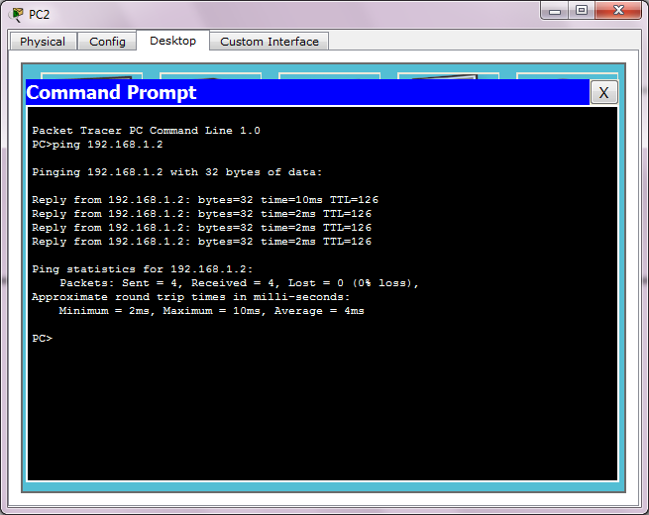

And now we check the Router0 by typing the following Command

Router#show crypto ipsec sa

We get the following output, as seen the number of packets encrypted is not zero (marked bold)
interface: Serial0/1/0
Crypto map tag: vpn-map, local addr 192.168.2.1

protected vrf: (none)
local ident (addr/mask/prot/port): (192.168.1.0/255.255.255.0/0/0)
remote ident (addr/mask/prot/port): (192.168.4.0/255.255.255.0/0/0)
current_peer 192.168.3.2 port 500
PERMIT, flags={origin_is_acl,}
#pkts encaps: 7, #pkts encrypt: 7, #pkts digest: 0
#pkts decaps: 6, #pkts decrypt: 6, #pkts verify: 0
#pkts compressed: 0, #pkts decompressed: 0
#pkts not compressed: 0, #pkts compr. failed: 0
#pkts not decompressed: 0, #pkts decompress failed: 0
#send errors 1, #recv errors 0

local crypto endpt.: 192.168.2.1, remote crypto endpt.:192.168.3.2
path mtu 1500, ip mtu 1500, ip mtu idb Serial0/1/0
current outbound spi: 0x4C85163A(1283790394)

inbound esp sas:
spi: 0x6F1C411E(1864122654)
transform: esp-aes esp-sha-hmac ,
in use settings ={Tunnel, }
conn id: 2004, flow_id: FPGA:1, crypto map: vpn-map
sa timing: remaining key lifetime (k/sec): (4525504/2848)
IV size: 16 bytes
replay detection support: N
Status: ACTIVE

inbound ah sas:

inbound pcp sas:

outbound esp sas:
spi: 0x4C85163A(1283790394)
transform: esp-aes esp-sha-hmac ,
in use settings ={Tunnel, }
conn id: 2005, flow_id: FPGA:1, crypto map: vpn-map
sa timing: remaining key lifetime (k/sec): (4525504/2848)
IV size: 16 bytes
replay detection support: N
Status: ACTIVE

outbound ah sas:

outbound pcp sas:

Step 4: Ping PC2 from PC0 (Creating NON interesting traffic)

Now we ping PC2 from PC0 (Not interesting traffic)
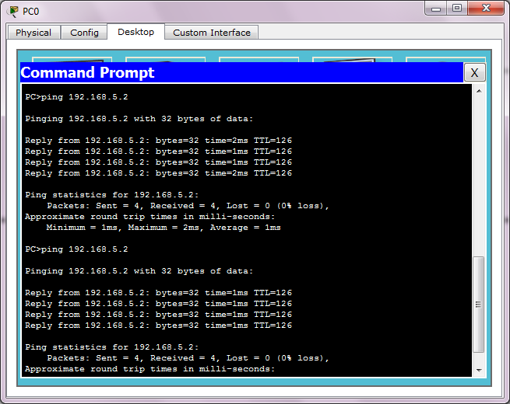

And now we check the Router0 by typing the following Command

Router#show crypto ipsec sa

We get the following output, as seen the number of encrypted packets do not change as compared to previous case

Router#show crypto ipsec sa

interface: Serial0/1/0
Crypto map tag: vpn-map, local addr 192.168.2.1

protected vrf: (none)
local ident (addr/mask/prot/port): (192.168.1.0/255.255.255.0/0/0)
remote ident (addr/mask/prot/port): (192.168.4.0/255.255.255.0/0/0)
current_peer 192.168.3.2 port 500
PERMIT, flags={origin_is_acl,}
#pkts encaps: 7, #pkts encrypt: 7, #pkts digest: 0
#pkts decaps: 6, #pkts decrypt: 6, #pkts verify: 0
#pkts compressed: 0, #pkts decompressed: 0
#pkts not compressed: 0, #pkts compr. failed: 0
#pkts not decompressed: 0, #pkts decompress failed: 0
#send errors 1, #recv errors 0

local crypto endpt.: 192.168.2.1, remote crypto endpt.:192.168.3.2
path mtu 1500, ip mtu 1500, ip mtu idb Serial0/1/0
current outbound spi: 0x4C85163A(1283790394)

inbound esp sas:
spi: 0x6F1C411E(1864122654)
transform: esp-aes esp-sha-hmac ,
in use settings ={Tunnel, }
conn id: 2004, flow_id: FPGA:1, crypto map: vpn-map
sa timing: remaining key lifetime (k/sec): (4525504/2693)
IV size: 16 bytes
replay detection support: N
Status: ACTIVE

inbound ah sas:

inbound pcp sas:

outbound esp sas:
spi: 0x4C85163A(1283790394)
transform: esp-aes esp-sha-hmac ,
in use settings ={Tunnel, }
conn id: 2005, flow_id: FPGA:1, crypto map: vpn-map
sa timing: remaining key lifetime (k/sec): (4525504/2693)
IV size: 16 bytes
replay detection support: N
Status: ACTIVE

outbound ah sas:

outbound pcp sas:

